AS ASSIGNMENT 2
Name: Anurag Arun Patil
Division: C
Roll Number: 67
What is GET Method?
It is primarily used for requesting a specific resource or retrieving data from a server. Here are some key points to understand about the "GET" method:
-
Definition and Usage: The "GET" method is used to request a representation of a specified resource from a web server . It is commonly used to retrieve data from a server, such as fetching HTML documents or accessing APIs.
-
Data Transmission: When using the "GET" method, the data is appended to the URL as query parameters. This means that the data is visible in the URL itself . For example, if you have a form with a "GET" method and the user submits the form, the form data will be included in the URL that appears in the browser's address bar.
-
Bookmarking and Caching: Since the data is included in the URL, the "GET" method allows users to bookmark the resulting page or share the URL with others. Additionally, the browser can cache the results of a "GET" request, which can improve performance when the same request is made again .
-
Limitations: There are some limitations to consider when using the "GET" method:
-
Data Length: If the form data set is large, with hundreds of characters, using the "GET" method may cause practical problems with implementations that cannot handle long URLs .
-
Non-ASCII Characters: If the form data contains non-ASCII characters, the "GET" method may not be applicable in principle, although it may work for ISO Latin 1 characters .
-
Visibility of Form Data: The "GET" method makes the form data visible in the URL, which may not be desirable in certain cases where you want to keep the form's functionality hidden from users .
CODE :
<!DOCTYPE html> <html>
<head>
<title>Registration Form - GET Method</title>
</head>
<body>
<h1>Registration Form - GET Method</h1>
<form action="registration.php" method="GET">
<label for="name">Name:</label>
<input type="text" id="name" name="name" required><br>
<label for="email">Email:</label>
<input type="email" id="email" name="email" required><br>
<input type="submit" value="Register">
</form>
</body>
</html>
OUTPUT:
What is POST Method?
The POST method in HTML is used to submit form data to a server. When a form is submitted using the POST method, the data is sent in the body of the HTTP request, rather than in the URL. This method is commonly used when data needs to be added or modified on the server, such as saving data to a database or uploading files.
To use the POST method in HTML, you need to specify the method attribute in the <form> tag as "post".
The POST method is particularly useful in the following scenarios:
-
Large form data: If the form data set is large, using the POST method is recommended. The GET method may have practical problems with implementations that cannot handle long URLs.
-
Non-ASCII characters: If the form data contains non-ASCII characters, such as accented characters, the POST method is more suitable. While the GET method may work for ISO Latin 1 characters, it is generally inapplicable for non-ASCII characters.
-
Data security: The POST method can be used to make the form data less visible to users. Unlike the GET method, the form data is not appended to the URL, making it less exposed. However, it's important to note that even with the POST method, hidden fields (<input type="hidden">) will still appear in the HTML source code.
The POST method is commonly used in conjunction with server-side technologies, such as PHP, Python, or Node.js, to process the form data and perform actions on the server .
CODE:
<!DOCTYPE html>
<html>
<head>
<title>Registration Form - POST Method</title>
</head>
<body>
<h1>Registration Form - POST Method</h1>
<form action="registration.php" method="POST">
<label for="name">Name:</label>
<input type="text" id="name" name="name" required><br>
<label for="email">Email:</label>
<input type="email" id="email" name="email" required><br>
<input type="submit" value="Register"> </form>
</body>
</html>
OUTPUT:
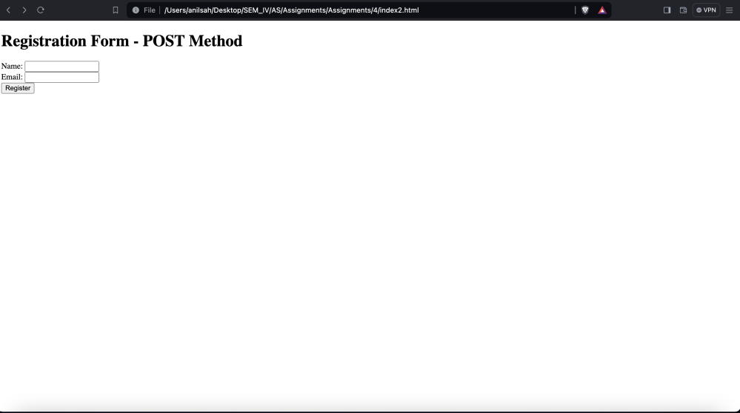

Security Differences between POST and GET Methods:
The POST and GET methods are both HTTP methods used in web applications, but they have different characteristics when it comes to security. Here are the key differences:
-
Data Transmission: The main difference between the two methods is how data is transmitted. With the GET method, the data is appended to the URL as query string parameters, while with the POST method, the data is sent in the request body.
-
Data Visibility: GET requests expose the data in the URL, making it visible to everyone who has access to the URL. This can be a security risk, especially when sensitive information like passwords or personal data is being transmitted. On the other hand, POST requests do not display the data in the URL, providing an additional layer of security.
-
Data Storage: GET parameters are stored in server logs and browser history, which can pose a security risk if sensitive information is included. POST parameters, on the other hand, are not stored in browser history or server logs, making them more secure in terms of data storage.
-
Data Alteration: GET requests make it easier to alter the data being submitted to the server, as the parameters are right there in the address bar and can be modified. This can lead to potential security vulnerabilities. In contrast, POST requests do not expose the data in the same way, making it more difficult to alter the data being sent.
-
HTTPS: Both GET and POST methods can be used with either HTTP or HTTPS protocols. However, using HTTPS (HTTP Secure) provides an additional layer of security by encrypting the data transmitted between the client and the server. This is particularly important when sensitive information is being transmitted.
It's important to note that while the POST method is generally considered more secure than the GET method, neither method alone provides complete security. Other security measures, such as input
validation, authentication, and authorization, should also be implemented to ensure the overall security of a web application.
Conclusion:
In summary, the POST method is generally considered more secure than the GET method in web applications. The POST method transmits data in the request body, keeping it hidden from the URL and providing better protection against data exposure and alteration. However, it's important to implement additional security measures and use HTTPS to ensure the overall security of a web application.

